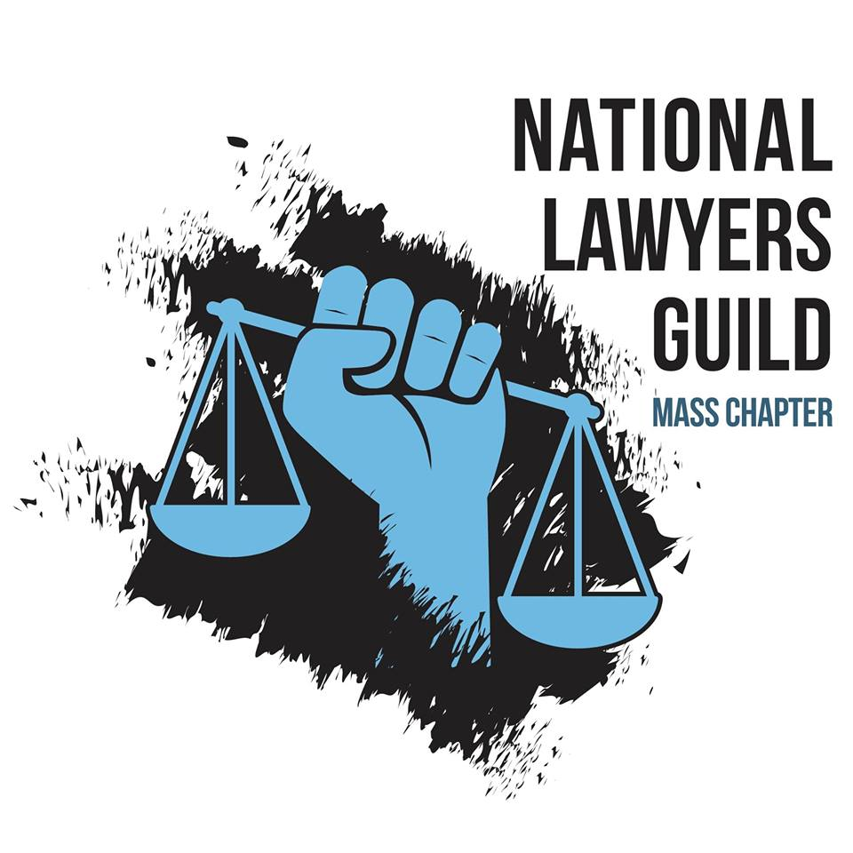

**ALERT FOR ACTIVISTS**

There has been a recent increase in activity by the FBI, ICE, State Police, and Homeland Security agents approaching climate change and pro-Palestinian activists in Massachusetts to ask them about their activities and organizations. The National Lawyers Guild-Massachusetts Chapter is issuing this alert to help activists respond to any such encounters with law enforcement.

**What to do if the FBI or other law enforcement officer**

**contact you for questioning**

If you are contacted by the FBI or other law enforcement agencies (ICE, Homeland Security, Secret Service, State Police, etc.) at home, work, or school, you have the ***absolute right not to answer any questions*** or speak to them at all:

* Given the current administration, there is nothing to be gained by any activist speaking to any law enforcement officer. If approached, you should say “***I do not wish to speak with you.*** ***I will not answer any questions. Please leave.***”
* Be polite, but assertive. You do not have to answer the door for them, or you can close the door of your home to the officer, **unless they have a warrant** to search your home or to arrest or detain someone.
* You have the right to talk to an attorney and can tell officers that you will not speak to them without your attorney being present.
* Write down the name, agency, and telephone number of any officer who calls or visits you, if they will provide that information without you having to answer their questions.
* ANY information you give to a law enforcement officer, even if it seems harmless, can be used against you or another activist. Lying to a federal officer is a crime. **Remaining silent is NOT a crime**.
* You are NOT required to allow any officer into your home without a warrant; always **ask to see any warrant** that they claim to have. If the officers do not have a warrant, you do not have to let them into your home. However, do not try to stop officers if they force their way into your home or office, as that would give them an excuse to arrest you. State loudly that they do not have your permission to enter.
* If officers say that they have a warrant for your arrest, you have a right to see the warrant, but you must go with the officers if you are informed that you are under arrest. However, you do not have to answer any questions until you consult an attorney.
* If you are arrested or detained, you should immediately state that you want an attorney and **REMAIN SILENT** otherwise. You can repeat “***I will not answer any questions without my attorney being present.***”

If the FBI or other law enforcement officials contact you about your activist actions, please contact the

NLG – Mass. Chapter immediately by calling 617-227-7335 or emailing us at [nlgmass-director@riseup.net](mailto:nlgmass-director@riseup.net).